**IMPROVING ZARA’S MOBILE APPLICATION’S USER INTERFACE**

**Part 3: High Fidelity Prototype and User Testing Plan**

CPS613

Dr. Somang Nam

Chloe Parentela

Dylan Rodrigues

Ghazal Mirsayyah

Omar Syed

Shantanu Singh

April 1, 2022

# Table of Contents

**Table of Contents** **2**

**Hi-fi Prototype & Redesign Decisions** **2**

**Link to prototype** **3**

General 3

Navigation Bar 3

Landing Page and Home Page 4

Search 5

Menu 5

Profile 6

Cart 7

Wishlist 8

Checkout 9

**DECIDE Framework** **10**

Determine the goals 11

Explore the questions 11

Choose the evaluation approach and methods 12

Identify the practical issues 12

Decide How to deal with the ethical issues 13

Evaluation, Analyze, Interpret and Present the data 13

**Appendix** **13**

List of Participant Tasks 14

Data Collection Protocol 14

Consent Form 15

Data Collection Form 17

# Hi-fi Prototype & Redesign Decisions

## Link to prototype

<https://www.figma.com/file/CEZv9yBqSiPFkQeEnn7gSY/CPS-613%3A-High-fidelity?node-id=0%3A1>

## General

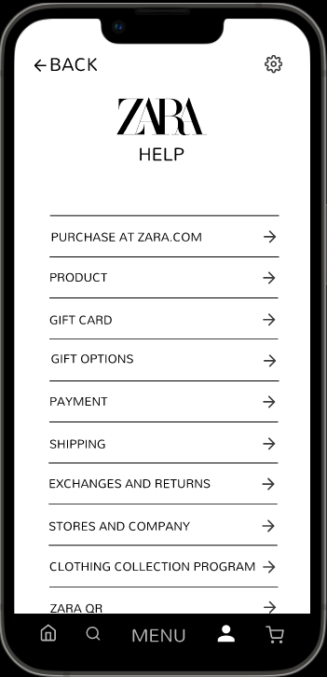 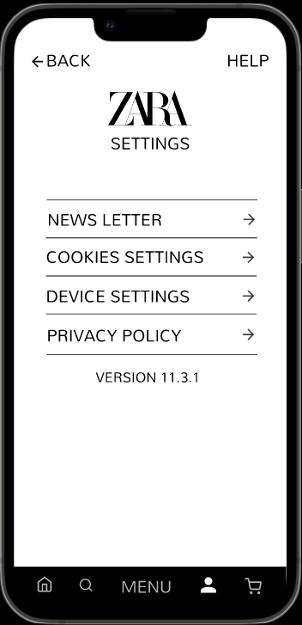

* To keep the platform bright and easy to work with, we followed a light color palette by using white backgrounds, with black text and buttons. We wanted the user to never struggle determining the functionality of each interactable aspect of the platform. The contrast in the background and text stands out even when the user is attempting to use the platform in broad daylight or pitch darkness. This prevents any icons, buttons, or any other functions from going unnoticed or hidden. For simplicity, we created a “Help” and settings button at the top of all pages for users to access in case they are struggling with the platform. Our prototype used Mandali font throughout the whole application for consistency.

## Navigation Bar



* For our navigation bar, once again we followed a black and white color palette selection, except this time, we made the background of the navigation bar black, while making the Icons and “Menu” text white. We used the opposite color scheme so that the user can quickly distinguish the navigation bar from the actual page, while remaining true to the original color scheme to ensure that the entire platform is clear and consistent.

## Landing Page and Home Page

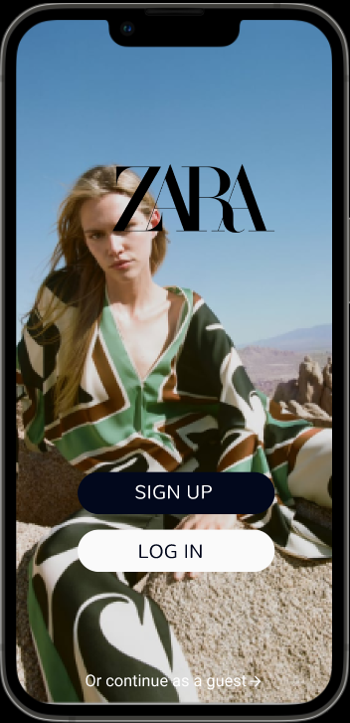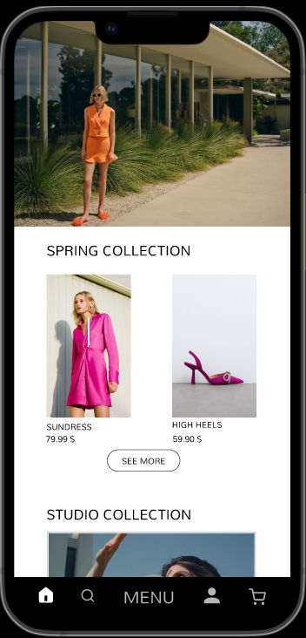

* We kept our landing page after sign in, bright and filled with just enough images to grasp the user’s attention but not overwhelm them, like how Zara’s original UI does. Since the landing page and the home page are the first pages the user is forced to interact with after login, we focused on attractive qualities that would reel users in and direct them to popular pages within the platform. We used only bright images of items available in the Zara store as well as providing options to navigate to the specific item in order to give off an immediate fashion friendly vibe. We used different font sizes of the same font format to be able to express consistency yet also making important aspects of the platform immediately visible. The original design of the app also included a lot of carousel interfaces on the home page, which were faced with negative feedback during our usability testing. Therefore we removed and replaced them with a mix of images and videos, to keep the page interactive but not too overwhelming.

## Search

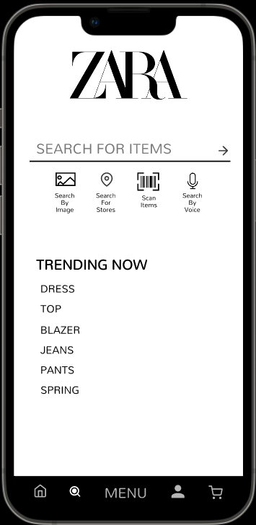

* We positioned the search icon right next to the landing page icon on the navigation bar since most users tend to jump to search immediately. We provided the user with the “Trending Now” list to aid in the search for common trending items, sticking to the same color palette and font style as the rest of the pages, using different font sizes to indicate importance and headers. Furthermore, to distinguish the search page as the active page, we made it brighter and thicker than the inactive icons in the navigation bar, and we added a circle in the middle.

## Menu

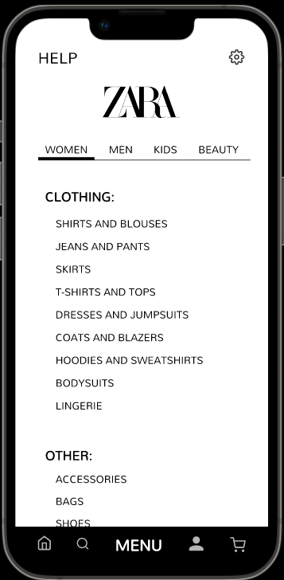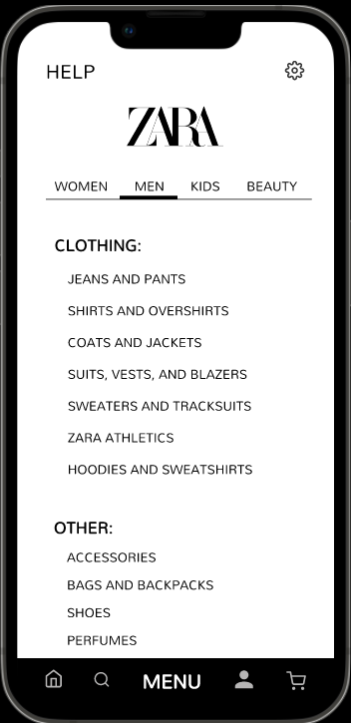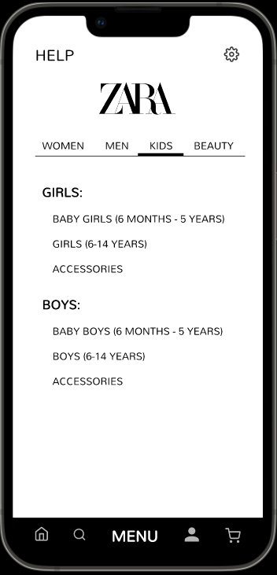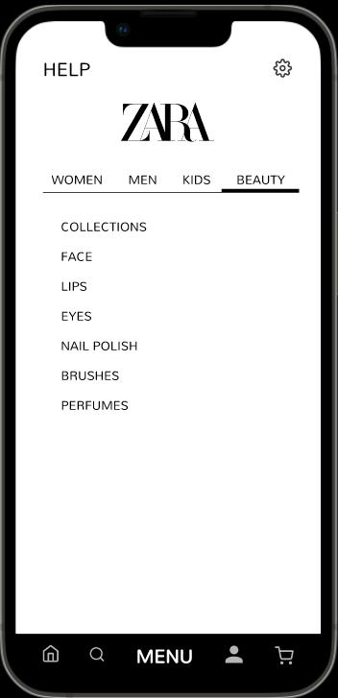

* In order to attract users and provide them with all available product options, we made the "MENU" icon in our navigation bar the largest icon. With a clear method of accessing the MENU bar, the users are able to immediately jump into product browsing according to their wants. For our search menu, we significantly reduced the amount of options to avoid overwhelming the user with so much content. We divided all items by Women, Men, Kids and Beauty, each section having their respective categories that are simple and easy to work with. For Women and Men, the items are distributed under two visible headers, “Clothing” and “Other”, that are bolded in large fonts to avoid any confusion. For kids, items are divided by gender and then further divided by age group. For beauty, we maintained a simple and accessible menu of all beauty products.

## Profile

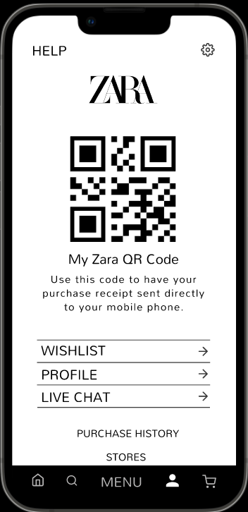 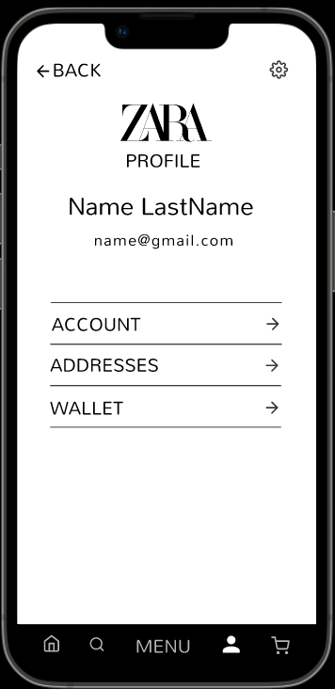 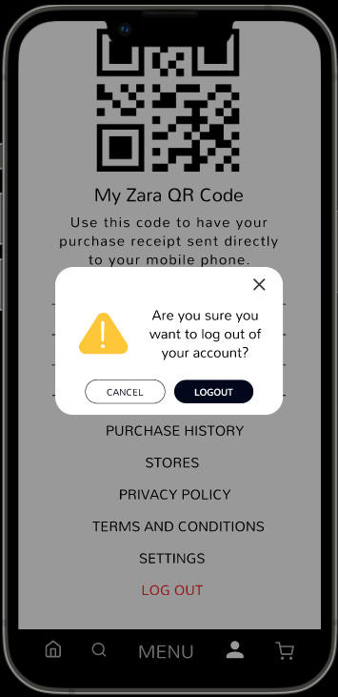

* The profile can be accessed by the human icon in the navigation bar on the right of the “MENU” button. In order to allow users to identify the profile section of the platform, we used the human icon commonly used on websites and phone applications. By using recognizable icons, the user does not have to face a steep learning curve when attempting to use the platform for their first time. In the profile page, we used large header buttons to signify the 4 primary functions of the profile page, “My Zara QR Code”, “WISHLIST”, “PROFILE” and “LIVE CHAT”. Users can also access the page’s secondary functions just below in a smaller, less prominent font size. Furthermore, to prevent the users from accidentally logging out of their account without intending to, we added a warning prompt that asks the user if they really want to log out before doing so.

## Cart

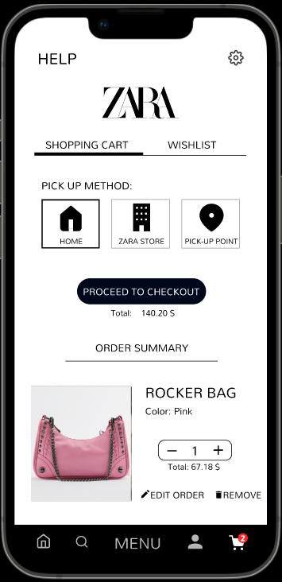 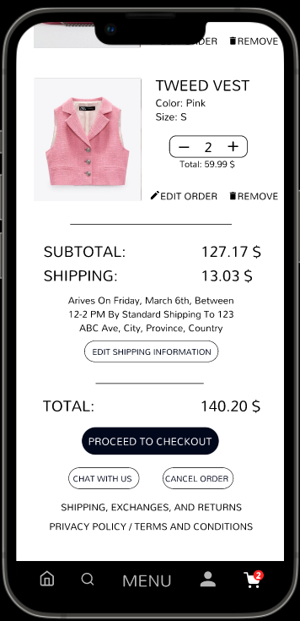

* The cart page is positioned last on the navigation bar since it is the last action performed by the user when attempting to purchase items. To keep the platform intuitive and easy to learn, we used a shopping cart icon to identify the cart page. The first thing users see from the top of the cart page is a category selection bar to clarify whether the user is accessing their shopping cart or wishlist. For the pick up method, we used both black and white text as well as icons to match the theme of the whole platform. By using a combination of icon and text, the pick up method selection becomes a lot more intuitive and quickly understood. When using the “Zara Store” and “Pick-up Point” as the pickup method, addresses are required to be inputted on a pop up page with an inverted theme of black background and white text to provide an obvious way to indicate a popup page from the actual cart page. The user can also use a map to pick the location. In the order summary, images of the items, as well as their details and price breakdown are all made visible in large fonts to avoid confusion. Options to cancel and edit orders as well to contact a live chat Zara representative are made available.

## Wishlist

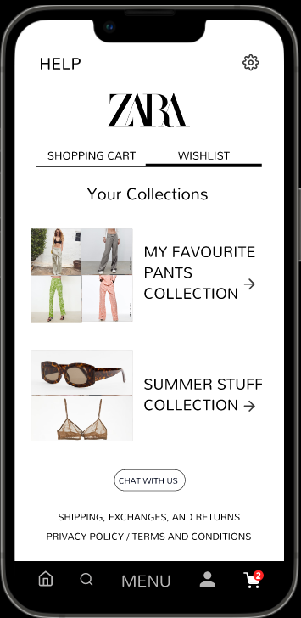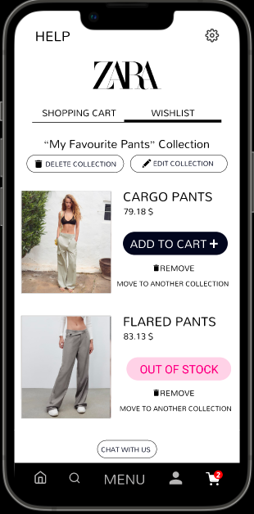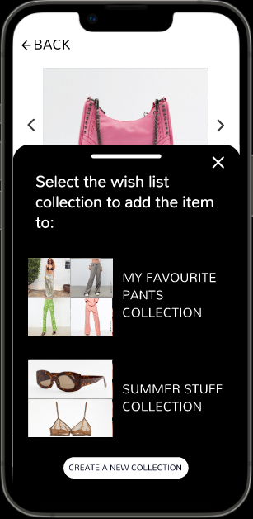

* The wishlist page can be accessed both from the profile icon and the shopping cart icon. To add an item to the wishlist, the user can either use the bookmark item in the list of items or the one in the single product pages. After clicking on the bookmark icon, the user is prompted to choose a wishlist collection to add the item to or make a new collection. The collection functionality was implemented to help the user organize their wish lists better. The user can also edit or remove wishlist collections by accessing it through the profile or the shopping cart icon.

## Checkout

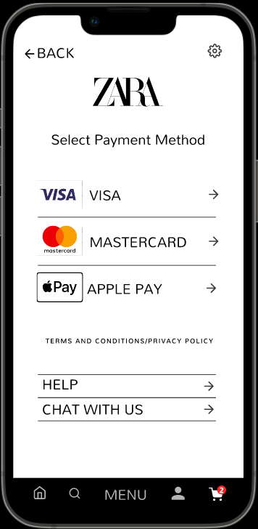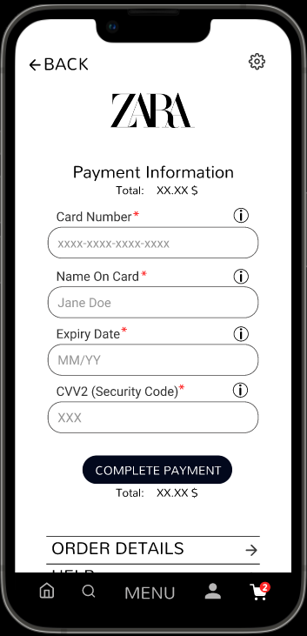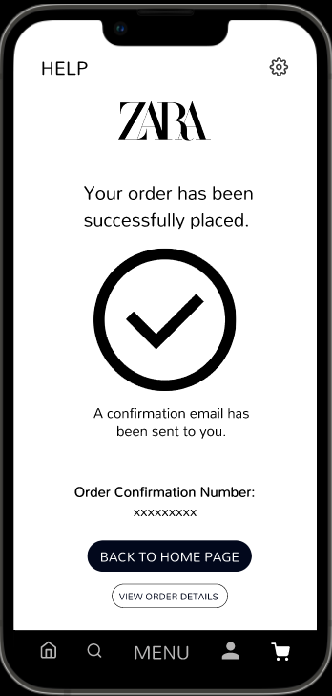

* In the shopping cart, we positioned the “PROCEED TO CHECKOUT” button in two different locations of the page. We also made them pop out by altering the background of the button significantly from the background of the rest of the page. This recognizability allows users to understand the next step of the process in purchasing their listed items in the order summary. Upon proceeding to the checkout button, the user is guided step by step to confirm and complete the order by inputting address and payment details. This step by step guide for order completion prevents confusion in the ordering process.

# 

# 

# DECIDE Framework

In order to properly fine tune the Zara application according to users’ needs and desires, we will frame our evaluation according to the DECIDE framework. Our redesigning effort will then proceed based on the results.

## **D**etermine the goals

Firstly, we will establish the goals of our redesign evaluation. We are seeking to know the usability experience of our initial hi-fi prototype. Our primary goals for this phase include the following:

* Determining the usability experience of new and returning users.
* Evaluate whether all groups of users are able to effectively find what they need with respect to the redesign.
* Determine if the visual components and functionality pass the System Usability Scale with a target score of at least 68.5.
* Analyze the effect of our redesign on the overall aesthetics of the current Zara application, whether it improves user satisfaction, and whether it is in line with Zara’s design principles.

## **E**xplore the questions

Next, we will formulate the questions that will help us meet the goals outlined above and get the information required by this evaluation study.

* To begin with, we gauge the users’ experience with the functionality of our redesign.
  + How did you find the size of the buttons in our redesign compared to the original one?
  + Were the live chat and help options easier to find?
  + Were the grouping of categories easier to understand and work with?
    - Was the sorting of clothes better organized?
    - Did you get better recommendations for clothes?
* We also asked basic demographic questions about the users and their overall opinions of the redesign.
  + What is your age and gender?
  + Have you used the Zara application before?
  + What type of device have you used?
  + How often do you shop online?
* We would also like to know where we can improve in terms of usability and user experience
  + Are there any features of the redesigned application which did not meet your expectations?
  + Are there any ways we can improve the functionality?

## **C**hoose the evaluation approach and methods

Our evaluation approach will involve a Google Forms survey where we ask the participants to go through the Figma hi-fi prototype and answer questions that we outlined above. Along with the survey questions, we will ask our survey participants to perform a few tasks in the redesigned app and rate their ease (on a scale of 1-5) to complete our tasks. We also intend to record the amount of time it takes the user to complete the tasks. The tasks can be found in the Appendix under **List of Participant Tasks**.

## **I**dentify the practical issues

In order to ensure that the surveys contain pertinent information which would allow us to collect useful data from our participants, we intend to do an internal trial run to identify and rectify any problems that might arise during the survey.

Our survey requires an Internet enabled mobile device or a desktop computer that would allow our hi-fi prototype simulation to run inside a browser. The hi-fi prototype is hosted on Figma which would allow the participants to experience the application, regardless of their device specifications. We also intend to ask the participants to share their screen while they perform the tasks, so that we can calculate and compare the time it takes for them to perform a list of tasks. This would require communication and screen-sharing using Zoom or similar softwares. The survey will contain instructions on what software to use if not already downloaded, directions for the user on how to record their screen and communicate with the surveyors. The user will be notified of this requirement by the survey facilitator before the beginning of the survey.

The target demographic for our survey are people who prefer to shop online. Although our intention is to get a holistic demographic consisting of people from all ages, as university students, we do concede that most of our participants would be from the same age group as us (18-24 years of age). There are also difficulties finding an adequate and varied amount of differently-abled users to ensure that our redesign meets accessibility requirements efficiently.

While our survey should not take more than 30 minutes, there might be participants who are not comfortable with that amount of time on the survey and will need to be reassured by the surveyors.

Since this is our second time conducting surveys and performing analysis on the results, with the previous instance helping us design our prototypes, the members of our team are experienced and knowledgeable in the overall process. In other words, we have the required expertise to ask the questions, collect the data, perform analysis and come up with actionable guidelines based on the results.

## **D**ecide How to deal with the ethical issues

It is incredibly important to ensure that the data and information entered by the participant is secure and anonymous.

* Our report will not contain information that directly links a participant’s identity to their answer.
* Participants will be asked to sign a consent form before beginning the survey which will explain the permissions needed when participating in the survey. Detailed information and terms of use will be provided.
* Our recordings of the user working with the application will not be shared publicly.
* All participants will be made aware of what type of information will be collected in the survey and asked to give consent before proceeding.
* All participants are allowed to leave at any point during the evaluation process.

The **Consent Form** can be viewed in the appendix of this report.

## **E**valuation, Analyze, Interpret and Present the data

Our data will mainly be sourced from the Google Forms that would be mandatory for each and every participant to complete. From screen sharing, we intend to record the amount of time it takes for a participant to perform a certain task. We also plan to expand on this portion of the framework in detail during the fourth iteration of our project in P4.

# Appendix

## List of Participant Tasks

This section contains a list of tasks that the participants have to do. These tasks will be recorded and timed.

1. Making an account
2. Searching for an item, possibly using filters
3. Adding an item to wishlist
4. Making a purchase
5. Finding certain buttons (e.g: privacy policy, help, etc)

## Data Collection Protocol

1. **Project Title:** Improving Zara’s Mobile Application’s User Interface
2. **Investigators:** Chloe Parentela, Dylan Rodrigues, Ghazal Mirsayyah, Omar Syed, and Shantanu Singh
3. **Purpose:** The purpose of our study is to gain insight about the effectiveness of our redesign of Zara’s mobile application. We intend to find out what aspects of the new Zara user interface are satisfactory to the users and where we can improve.
4. **Process to be followed:** We will explain to our study participants the purpose of this study, and have them sign a consent form that gives us permission to share their mobile or desktop screen. We will then ask the participants to take some time to interact with the redesigned Zara mobile application, testing as many new features as they can. Once the user has familiarized themself with the application, we will give the participants access to the survey to fill out while also having the redesigned Zara application running next to them if they need to refer back to it. All concerns and noticeable issues will then be recorded in the survey data.
5. **Participant Selection:** Participants are generally chosen by their age groups, with our ideal target between the ages of 18-23 as well as some users outside the age range for a more rounded data set.
6. **Relationships:** Our relationship with the participants are not restrictive. As long as the participants are willing to follow the instructions and are able to provide important data, the relationship between us and the participants does not play a significant role.
7. **Risk and Benefit:** There is minimal to no risk for our respondents when participating in our study. Only thing required from the participants is some time and focus for best results. The benefits would be that participant data would provide us a better understanding of the possible issues in the user interface and how we can plan to improve on them. Participants are free to withdraw from the study at any time without the need to provide any explanation.
8. **Consent Details:** We intend to explain to all participants the purpose of the study and the logistics of the attached consent form to them. The process of the study will only continue if the participants agree with the consent form and sign it digitally.
9. **Compensations:** There is no compensation for the participants within this study.
10. **Information Sought:** The information sought is present in the survey which will be conducted at the participant’s own time.
11. **Confidentiality:** All information provided by the participants will be kept confidential by the investigators. Aside from the purposes of this study, the only other use of all information provided will be for the submission of the assignment, which will make it accessible by our professor as well as his TAs.

## Consent Form

**Improving Zara’s Mobile Application’s User Interface**

I hereby consent to participate in a study conducted by Chloe Parentela, Dylan Rodrigues, Ghazal Mirsayyah, Omar Syed, and Shantanu Singh for an assignment for Ryerson University’s CPS 613 course, Human-Computer Interaction.

I agree to participate in this study, the purpose of which is evaluating the redesigned Zara's mobile application from the users' perspective.

I understand that:

1. The procedures to be used are answering a few demographic questions, using different functionalities of the redesigned application, and filling out a questionnaire about them.
2. I agree that my mobile/desktop screen will be shared and used by the survey facilitators to study and gain insights on user behavior.
3. I will receive no compensation for my participation.
4. I am free to withdraw before or at any time during the study without the need to give any explanation.
5. All materials and results will be kept confidential, and, in particular, my name and any identifying or identified information will not be associated with the data.

**Participant**

| What is your name? |  |
| --- | --- |
| Please read the above conditions and sign your initials if you consent to them. |  |
| Today’s Date |  |



**Investigators**

| **Name** | **Signature/Initials** |
| --- | --- |
| Chloe Parentela | C.P. |
| Dylan Rodrigues | D.R. |
| Ghazal Mirsayyah | G.M. |
| Omar Syed | O.S. |
| Shantanu Singh | S.S. |

## Data Collection Form

| **Demographic Questions** | |
| --- | --- |
| 1. Which gender identity do you most identify with? | * Woman (Cisgender or Trans) * Man (Cisgender or Trans) * Non-binary (Any of the subgroups) * Two-Spirit * Other - Please indicate: _______ * Prefer not to say |
| 2. What is your age? | * 18 - 23 * 24 - 29 * 30 - 35 * 36 - 40 * 41+, please indicate: _______ |
| 3. How often do you shop online? | * Never (0-2 times a year) * Rarely (1-2 times every season) * Sometimes (1-2 times a month) * Often (1-2 times a week) * Frequently (more than twice a week) |
| 4. Have you ever used Zara’s app before? | * Yes * No * I don’t remember |
| 5. What type of device do you use the most for the app? | * Android * iOS * Other: ________ |
| 7. Do you have any accessibility requirements? If yes, what is it? (optional) |  |

| **Tasks** |
| --- |
| | **Task 1 - Starting from the Login In/Sign Up Page, Create an Account.** | | | --- | --- | | 1. How long do you think it should take to achieve this task? Answer in Seconds (s). Please enter a whole number. You do not have to be accurate |  | | 2. How would you rate the complexity of this task? | * 1 - Very Difficult * 2 - Somewhat Difficult * 3 - Neutral * 4 - Easy * 5 - Very Easy | | 3. How satisfied were you with the re-designed app with respect to this task? | * 1 - Very Dissatisfied * 2 - Somewhat Dissatisfied * 3 - Neutral * 4 - Easy Satisfied * 5 - Very Satisfied | | Suggestions or Feedback (optional) |  |  | **Task 2 - Searching for an Item: From the Home Page, please find any Pink Colored shoe and add it to your Cart** | | | --- | --- | | 1. How long do you think it should take to achieve this task? Answer in Seconds (s). Please enter a whole number. You do not have to be accurate |  | | 2. How would you rate the complexity of this task? | * 1 - Very Difficult * 2 - Somewhat Difficult * 3 - Neutral * 4 - Somewhat Easy * 5 - Very Easy | | 3. How satisfied were you with the re-designed app with respect to this task? | * 1 - Very Dissatisfied * 2 - Somewhat Dissatisfied * 3 - Neutral * 4 - Easy Satisfied * 5 - Very Satisfied | | Suggestions or Feedback |  |  | **Task 3 - Starting from the home screen, please find any item and add it to your Wish List.** | | | --- | --- | | 1. How long do you think it should take to achieve this task? Answer in Seconds (s). Please enter a whole number. You do not have to be accurate |  | | 2. How would you rate the complexity of this task? | * 1 - Very Difficult * 2 - Somewhat Difficult * 3 - Neutral * 4 - Easy * 5 - Very Easy | | 3. How satisfied were you with the re-designed app with respect to this task? | * 1 - Very Dissatisfied * 2 - Somewhat Dissatisfied * 3 - Neutral * 4 - Easy Satisfied * 5 - Very Satisfied | | Suggestions or Feedback |  |  | **Task 4 - Making a Purchase: From the home page, go to the Cart and purchase the items available in your Cart** | | | --- | --- | | 1. How long do you think it should take to achieve this task? Answer in Seconds (s). Please enter a whole number. You do not have to be accurate |  | | 2. How would you rate the complexity of this task? | * 1 - Very Difficult * 2 - Somewhat Difficult * 3 - Neutral * 4 - Easy * 5 - Very Easy | | How satisfied were you with the re-designed app with respect to this task? | * 1 - Very Dissatisfied * 2 - Somewhat Dissatisfied * 3 - Neutral * 4 - Easy Satisfied * 5 - Very Satisfied | | Suggestions or Feedback |  |  | **Task 5 - Starting from the Home Page, please find the Live Chat Screen** | | | --- | --- | | 1. How long do you think it should take to achieve this task? Answer in Seconds (s). Please enter a whole number. You do not have to be accurate |  | | 2. How would you rate the complexity of this task? | * 1 - Very Difficult * 2 - Somewhat Difficult * 3 - Neutral * 4 - Easy * 5 - Very Easy | | 3. How satisfied were you with the re-designed app with respect to this task? | * 1 - Very Dissatisfied * 2 - Somewhat Dissatisfied * 3 - Neutral * 4 - Easy Satisfied * 5 - Very Satisfied | | Suggestions or Feedback |  | |

| **SUS Questions** |
| --- |
| **Rate your level of agreement the following statements regarding Zara's mobile application:**   |  | Strongly Disagree | Disagree | Neutral | Agree | Strongly Agree | | --- | --- | --- | --- | --- | --- | | 1) I think that I would like to use this system frequently. |  |  |  |  |  | | 2) I found the system unnecessarily complex. |  |  |  |  |  | | 3) I thought the system was easy to use. |  |  |  |  |  | | 4) I think that I would need the support of a technical person to be able to use this system. |  |  |  |  |  | | 5) I found the various functions in this system were well integrated. |  |  |  |  |  | | 6) I thought there was too much inconsistency in this system. |  |  |  |  |  | | 7) I would imagine that most people would learn to use this system very quickly. |  |  |  |  |  | | 8) I found the system very cumbersome to use. |  |  |  |  |  | | 9) I felt very confident using the system. |  |  |  |  |  | | 10) I needed to learn a lot of things before I could get going with this system. |  |  |  |  |  | |

| **UI Elements Questions** |
| --- |
| **1. How satisfied were you with the following regarding the app's buttons?**   |  | Very Dissatisfied | Somewhat Dissatisfied | Neutral | Somewhat Satisfied | Very Satisfied | | --- | --- | --- | --- | --- | --- | | Size of the buttons |  |  |  |  |  | | Distinguishability |  |  |  |  |  | | Readability |  |  |  |  |  | | Discoverability |  |  |  |  |  | |
| **2. How easy was finding the following buttons?**   |  | Very Easy | Somewhat Easy | Nor Easy or Difficult | Somewhat Difficult | Very Difficult | | --- | --- | --- | --- | --- | --- | | The “Help” button |  |  |  |  |  | | The “Settings” button |  |  |  |  |  | | The “Live Chat” button |  |  |  |  |  | | The “Privacy Policy” and “Terms of Use” buttons |  |  |  |  |  | |
| **3. How satisfied were you with the following regarding the app's menu categories?**   |  | Very Dissatisfied | Somewhat Dissatisfied | Neutral | Somewhat Satisfied | Very Satisfied | | --- | --- | --- | --- | --- | --- | | Number of items |  |  |  |  |  | | Font size |  |  |  |  |  | | Division of general categories (Men, Women, Kids, Beauty) |  |  |  |  |  | | Sorting clothes by different criteria |  |  |  |  |  | | Figuring out your size for Zara |  |  |  |  |  | | Finding your size |  |  |  |  |  | | The overall layout of the menu |  |  |  |  |  | |
| **4. How easy were the following operations?**   |  | Very Easy | Somewhat Easy | Nor Easy or Difficult | Somewhat Difficult | Very Difficult | | --- | --- | --- | --- | --- | --- | | Finding clothing items |  |  |  |  |  | | Searching for items |  |  |  |  |  | | Filtering search |  |  |  |  |  | |
| **5. How satisfied were you with the following regarding the app's carousel interfaces?**   |  | Very Dissatisfied | Somewhat Dissatisfied | Neutral | Somewhat Satisfied | Very Satisfied | | --- | --- | --- | --- | --- | --- | | Swiping through the content |  |  |  |  |  | | The swipe indicator’s visibility |  |  |  |  |  | |